Cells to Tissues
Cells are the _______________ blocks of all living things.
Tissue=a group of cells working together to perform a particular function.
There are 4 main types of tissue
Tissue type | Description | Example
Connective | The living cells are imbedded in a framework called a ____________ | Bone  Cartilage  blood | 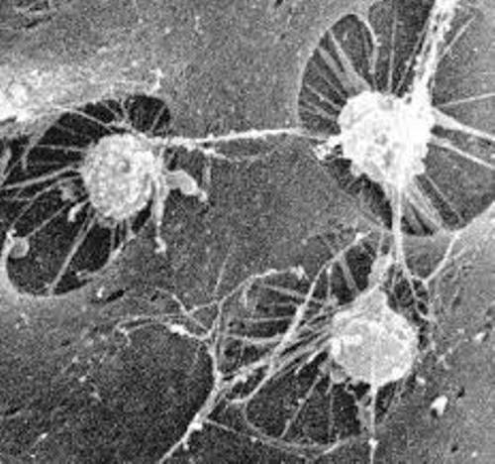  Hard matrix  Bone cell
Nervous | Caries ______ round the body. Carries nerve impulses. | Sensory neurons  Motor neurons | 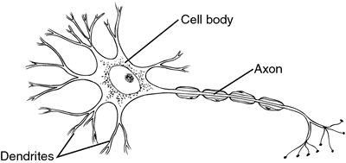
Epithelial | Lines organs and glands | Skin  And lining  Of  organs
Muscle | Can contract. This means it can get ___________. It helps us _______ things. | Skeletal muscle. This is the muscle that is attached to the _______. When it contracts it allows us to move our ______________.  Cardiac muscle when it contracts it makes the ________ beat.  Smooth muscle when it contracts it helps move through the digestive system. | 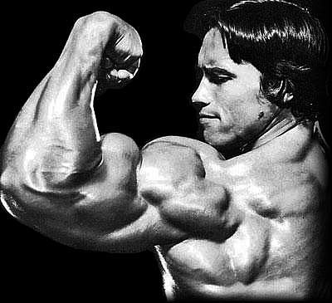

Example | Classify as one of the 4 tissue types. ______________, _____________, ____________, or ____________
The lining of the stomach
The biceps in the arms
The tissue that contracts to make the heart beat

The skull
The cells that make up the brain

In connective tissue the living cells are imbedded in __________________. The matrix is like a frame work. In bones the matrix is made of a hard material called Calcium Phosphate. Bone cells are called osteocytes.


